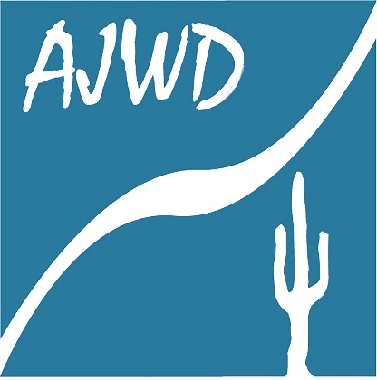
NEWS RELEASE
For More Information Contact:

Michael Loggins, PE, CPM
Director, Apache Junction Water District
(480) 982-6030
mloggins@ajcity.net

FOR IMMEDIATE RELEASE
Sept. 24, 2020

Apache Junction Water District Budget Approved with Slight Rate Increase

APACHE JUNCTION – The Apache Junction Water District (AJWD) is committed to providing safe and reliable drinking water to our customers. With this commitment comes the responsibility to ensure that infrastructure improvements are made, and that the water system remains financially sustainable.

This year major improvements to the water system will include:

- Design and construction of a raw water impound at the Superstition Area Water Plant Phase 1 of 2

- Utility Billing Software

Under the budget approved July 7 by the Water District board, the rates for customers within the city limits will increase approximately 2 percent, which translates to a bill increase of approximately $1.37 a month for the average customer using less than 7,500 gallons per month. Rates for customers living in the county will increase approximately 4.7 percent, which translates to a bill increase of approximately $3.47 a month for the average customer using less than 7,500 gallons per month.

The increase is part of the annual budget and rate setting process, which includes reviewing operating expenses and equipment replacement costs, leading to the rate adjustment. The rate schedule is available online at www.ajwaterdistrict.org, or upon request. The new rates will go into effect Oct. 1.

“The Apache Junction Water District makes every effort to minimize rate adjustments,” District Director Michael Loggins said. “We care about the potential impact this may have on our customers so we try and take an approach that is reasonable, sensible and responsible.”

For more information, you can reach the Apache Junction Water District at (480) 982-6030.

###

